**Name: Session:**

**Programming II**

**Lab Exercise 3.24.2020**

In this exercise, you will build 3 applications. The first application is a resistor color code decoder. The second two are Zodiac sign calculator based on the user’s birthday. The first Zodiac display program will get the user’s birthday from a text box. The second Zodiac display program will get the user’s birthday from a monthlyCalendar control.

When you complete these applications, print a screen shot of each running application. Attach to this sheet and turn in.

On the server, you will find started code for each of these projects.

**Resistor Color Code Decoder**

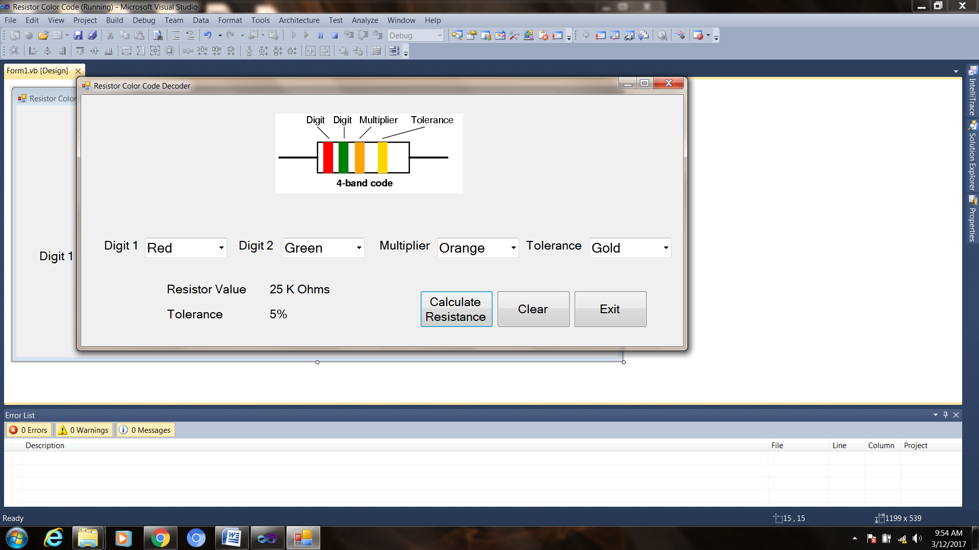

pbMultipler

pbTolerance

pbDigit1

pbDigit2

Note: the resistor picture has 4 Picture Boxes (pbDigit1, pbDigit2, pbMultiplier, and pbTolerance)

1. Open the project
2. Create the following global variables

int digit1, digit2, tolerance;

double multiplier;

1. Add the following code to the cboDigit1_SelectedIndexChanged event handler

digit1 = cboDigit1.SelectedIndex;

switch (cboDigit1.SelectedIndex)

{

case 0:

pbDigit1.BackColor = Color.Black;

break;

case 1:

pbDigit1.BackColor = Color.Brown;

break;

case 2:

pbDigit1.BackColor = Color.Red;

break;

case 3:

pbDigit1.BackColor = Color.Orange;

break;

case 4:

pbDigit1.BackColor = Color.Yellow;

break;

case 5:

pbDigit1.BackColor = Color.Green;

break;

case 6:

pbDigit1.BackColor = Color.Blue;

break;

case 7:

pbDigit1.BackColor = Color.Violet;

break;

case 8:

pbDigit1.BackColor = Color.Gray;

break;

case 9:

pbDigit1.BackColor = Color.White;

break;

}

1. Repeat step 3 for the cboDigit2_SelectedIndexChanged event handler. Be sure to change the PictureBox reference and variable and ComboBox names.
2. Add the following code to the cboMultiplier_SelectedIndexChanged event handler.

multiplier = Math.Pow(10, cboMultiplier.SelectedIndex);

switch (cboMultiplier.SelectedIndex)

{

case 0:

pbMultiplier.BackColor = Color.Black;

break;

case 1:

pbMultiplier.BackColor = Color.Brown;

break;

case 2:

pbMultiplier.BackColor = Color.Red;

break;

case 3:

pbMultiplier.BackColor = Color.Orange;

break;

case 4:

pbMultiplier.BackColor = Color.Yellow;

break;

case 5:

pbMultiplier.BackColor = Color.Green;

break;

case 6:

pbMultiplier.BackColor = Color.Blue;

break;

case 7:

pbMultiplier.BackColor = Color.Violet;

break;

case 8:

pbMultiplier.BackColor = Color.Gray;

break;

case 9:

pbMultiplier.BackColor = Color.White;

break;

case 10:

pbMultiplier.BackColor = Color.Gold;

multiplier = Math.Pow(10, -1);

break;

case 11:

pbMultiplier.BackColor = Color.Silver;

multiplier = Math.Pow(10, -2);

break;

}

1. Add the following code to the cboTolerance_SelectedIndexChanged event handler

switch (cboTolerance.SelectedIndex)

{

case 0:

pbTolerance.BackColor = Color.Gold;

tolerance = 5;

break;

case 1:

pbTolerance.BackColor = Color.Silver;

tolerance = 10;

break;

case 2:

pbTolerance.BackColor = Color.LightGray;

tolerance = 20;

break;

}

1. Add the following code to the calcValue function. This function is called by the btnCalc_Click event.

double value;

value = (10 * digit1 + digit2) * multiplier;

if (value > 1000000000.0)

lblValue.Text = (value / 1000000000.0).ToString() + " G Ohms";

else if (value > 1000000.0)

lblValue.Text = (value / 1000000.0).ToString() + " M Ohms";

else if (value > 1000.0)

lblValue.Text = (value / 1000.0).ToString() + " K Ohms";

else

lblValue.Text = value.ToString() + " Ohms";

lblTolerance.Text = tolerance + "%";

1. Add the following code to the btnClear_Click event handler

cboDigit1.Text = "";

cboDigit2.Text = "";

cboMultiplier.Text = "";

cboTolerance.Text = "";

lblValue.Text = "";

lblTolerance.Text = "";

pbDigit1.BackColor = Color.LightGray;

pbDigit2.BackColor = Color.LightGray;

pbMultiplier.BackColor = Color.LightGray;

pbTolerance.BackColor = Color.LightGray;

**Zodiac I**

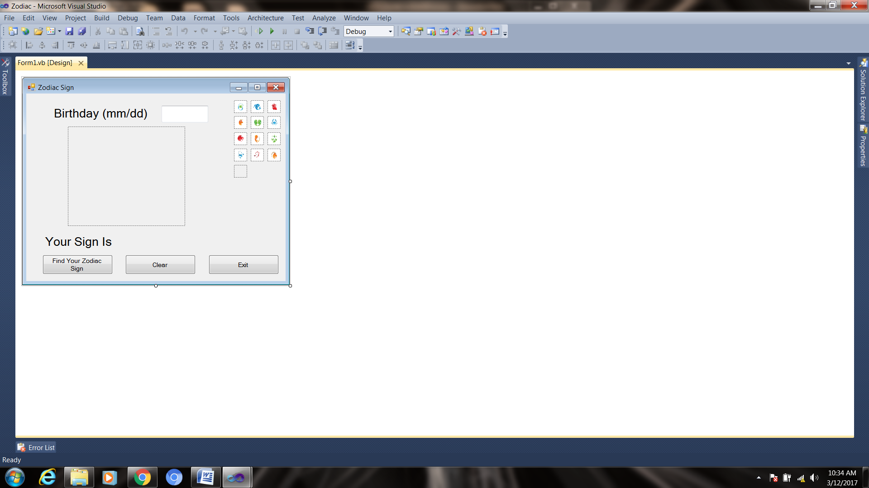 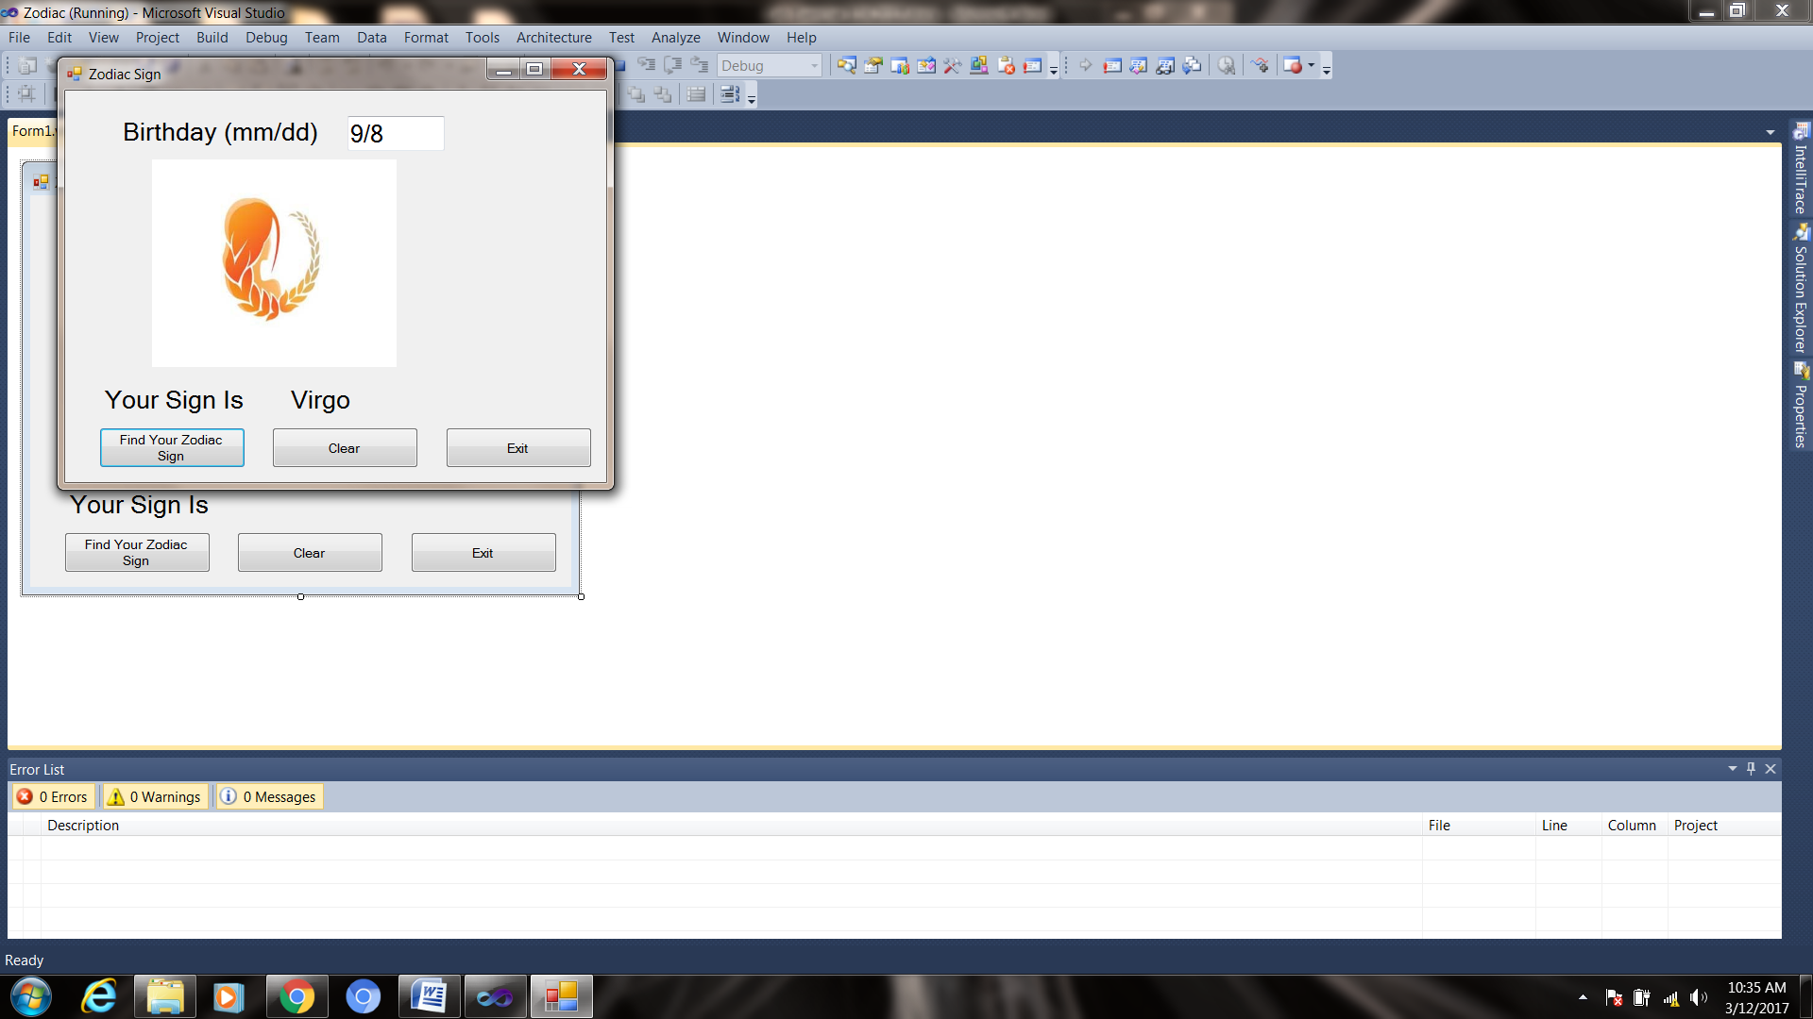

1. Open the project
2. Add the following global variable to define dates

DateTime startAqarius = new DateTime(DateTime.Now.Year, 1, 20);

DateTime endAqarius = new DateTime(DateTime.Now.Year, 2, 18);

DateTime startPisces = new DateTime(DateTime.Now.Year, 2, 19);

DateTime endPisces = new DateTime(DateTime.Now.Year, 3, 20);

DateTime startAries = new DateTime(DateTime.Now.Year, 3, 21);

DateTime endAries = new DateTime(DateTime.Now.Year, 4, 19);

DateTime startTaurus = new DateTime(DateTime.Now.Year, 4, 20);

DateTime endTaurus = new DateTime(DateTime.Now.Year, 5, 20);

DateTime startGemini = new DateTime(DateTime.Now.Year, 5, 21);

DateTime endGemini = new DateTime(DateTime.Now.Year, 6, 20);

DateTime startCancer = new DateTime(DateTime.Now.Year, 6, 21);

DateTime endCancer = new DateTime(DateTime.Now.Year, 7, 22);

DateTime startLeo = new DateTime(DateTime.Now.Year, 7, 23);

DateTime endLeo = new DateTime(DateTime.Now.Year, 8, 22);

DateTime startVirgo = new DateTime(DateTime.Now.Year, 8, 23);

DateTime endVirgo = new DateTime(DateTime.Now.Year, 9, 22);

DateTime startLibra = new DateTime(DateTime.Now.Year, 9, 23);

DateTime endLibra = new DateTime(DateTime.Now.Year, 10, 22);

DateTime startScorpio = new DateTime(DateTime.Now.Year, 10, 23);

DateTime endScorpio = new DateTime(DateTime.Now.Year, 11, 21);

DateTime startSagittarius = new DateTime(DateTime.Now.Year, 11, 23);

DateTime endSagittarius = new DateTime(DateTime.Now.Year, 12, 21);

DateTime startCapricorn = new DateTime(DateTime.Now.Year, 12, 22);

DateTime endCapricorn = new DateTime(DateTime.Now.Year+1, 1, 19);

1. Add the following code to the btnSign_Click event handler

DateTime birthday;

string[] d = txtBirthday.Text.Split('/');

DateTime temp = DateTime.Now;

int year = temp.Year;

int month = Convert.ToInt32(d[0]);

int day = Convert.ToInt32(d[1]);

birthday = new DateTime(year, month, day);

if (birthday >= startAqarius && birthday <= endAqarius)

{

this.lblSign.Text = "Aqarius";

pbZodiac.Image = pbAquarius.Image;

}

else if (birthday >= startPisces && birthday <= endPisces)

{

this.lblSign.Text = "Pisces";

pbZodiac.Image = pbPisces.Image;

}

else if (birthday >= startAries && birthday <= endAries)

{

this.lblSign.Text = "Aries";

pbZodiac.Image = pbAries.Image;

}

else if (birthday >= startTaurus && birthday <= endTaurus)

{

this.lblSign.Text = "Taurus";

pbZodiac.Image = pbTaurus.Image;

}

else if (birthday >= startGemini && birthday <= endGemini)

{

this.lblSign.Text = "Gemini";

pbZodiac.Image = pbGemini.Image;

}

else if (birthday >= startCancer && birthday <= endCancer)

{

this.lblSign.Text = "Cancer";

pbZodiac.Image = pbCancer.Image;

}

else if (birthday >= startLeo && birthday <= endLeo)

{

this.lblSign.Text = "Leo";

pbZodiac.Image = pbLeo.Image;

}

else if (birthday >= startVirgo && birthday <= endVirgo)

{

this.lblSign.Text = "Virgo";

pbZodiac.Image = pbVirgo.Image;

}

else if (birthday >= startLibra && birthday <= endLibra)

{

this.lblSign.Text = "Libra";

pbZodiac.Image = pbLibra.Image;

}

else if (birthday >= startScorpio && birthday <= endScorpio)

{

this.lblSign.Text = "Scorpio";

pbZodiac.Image = pbScorpio.Image;

}

else if (birthday >= startSagittarius && birthday <= endSagittarius)

{

this.lblSign.Text = "Sagittarius";

pbZodiac.Image = pbSagittarius.Image;

}

else

{

this.lblSign.Text = "Capricorn";

pbZodiac.Image = pbCapricorn.Image;

}

1. Add the following code to the btnClear_Click event handler

lblSign.Text = "";

txtBirthday.Text = "";

txtBirthday.Focus();

pbZodiac.Image = pbNull.Image;

**Zodiac with Calendar**

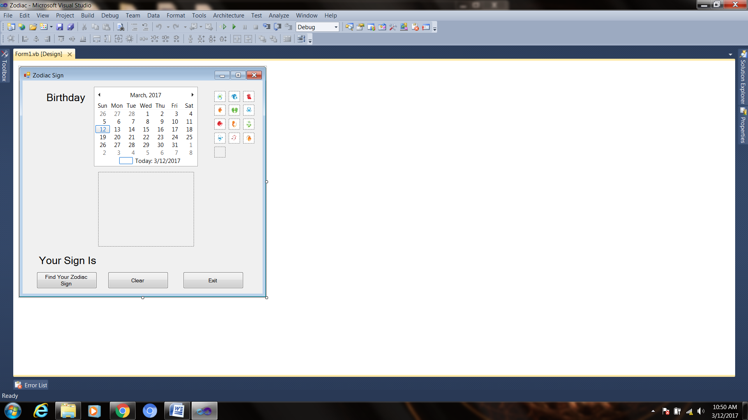 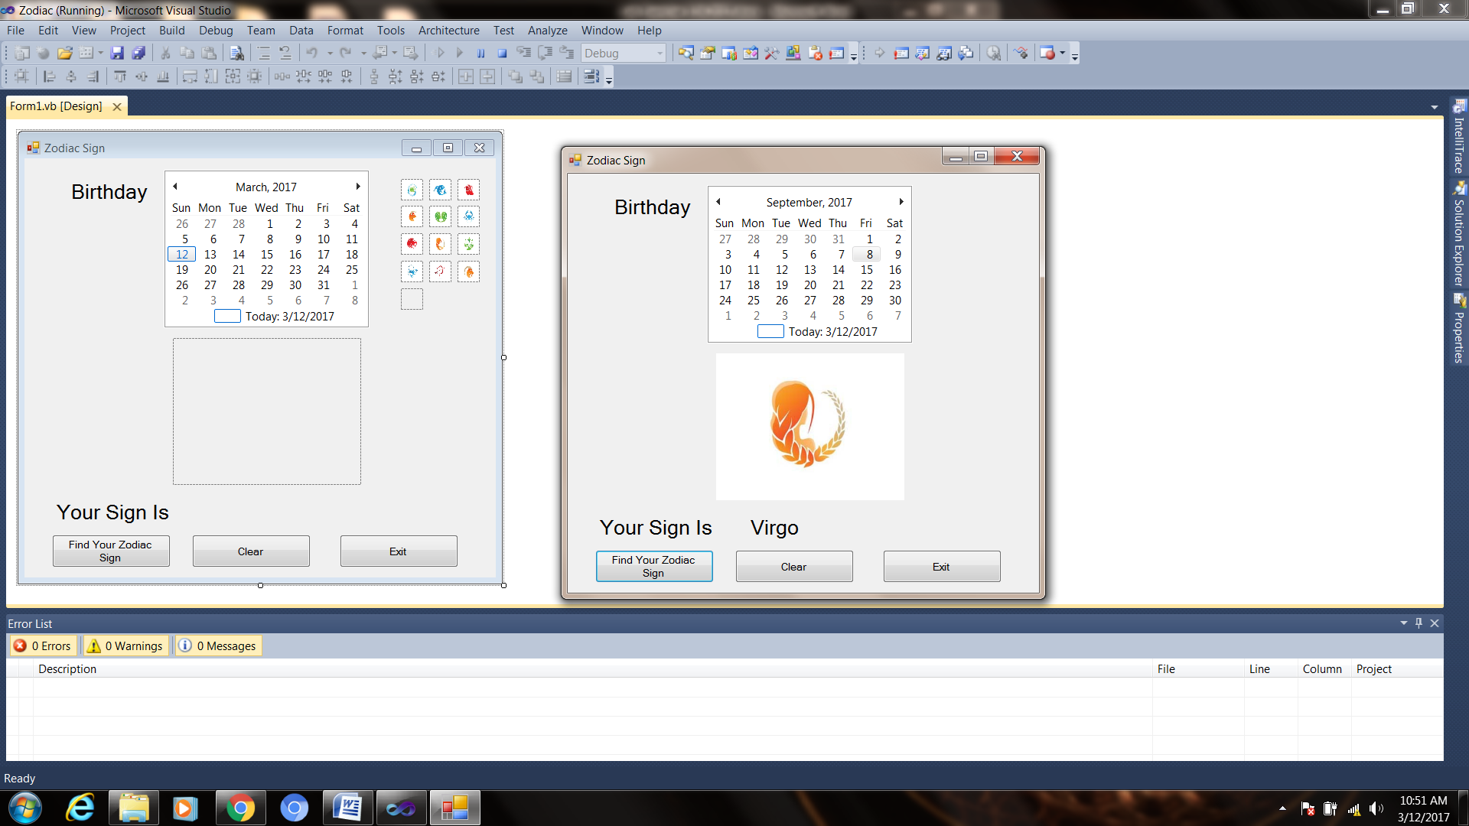

1. Open the project
2. Add the following global variable to define dates

DateTime startAqarius = new DateTime(DateTime.Now.Year, 1, 20);

DateTime endAqarius = new DateTime(DateTime.Now.Year, 2, 18);

DateTime startPisces = new DateTime(DateTime.Now.Year, 2, 19);

DateTime endPisces = new DateTime(DateTime.Now.Year, 3, 20);

DateTime startAries = new DateTime(DateTime.Now.Year, 3, 21);

DateTime endAries = new DateTime(DateTime.Now.Year, 4, 19);

DateTime startTaurus = new DateTime(DateTime.Now.Year, 4, 20);

DateTime endTaurus = new DateTime(DateTime.Now.Year, 5, 20);

DateTime startGemini = new DateTime(DateTime.Now.Year, 5, 21);

DateTime endGemini = new DateTime(DateTime.Now.Year, 6, 20);

DateTime startCancer = new DateTime(DateTime.Now.Year, 6, 21);

DateTime endCancer = new DateTime(DateTime.Now.Year, 7, 22);

DateTime startLeo = new DateTime(DateTime.Now.Year, 7, 23);

DateTime endLeo = new DateTime(DateTime.Now.Year, 8, 22);

DateTime startVirgo = new DateTime(DateTime.Now.Year, 8, 23);

DateTime endVirgo = new DateTime(DateTime.Now.Year, 9, 22);

DateTime startLibra = new DateTime(DateTime.Now.Year, 9, 23);

DateTime endLibra = new DateTime(DateTime.Now.Year, 10, 22);

DateTime startScorpio = new DateTime(DateTime.Now.Year, 10, 23);

DateTime endScorpio = new DateTime(DateTime.Now.Year, 11, 21);

DateTime startSagittarius = new DateTime(DateTime.Now.Year, 11, 23);

DateTime endSagittarius = new DateTime(DateTime.Now.Year, 12, 21);

DateTime startCapricorn = new DateTime(DateTime.Now.Year, 12, 22);

DateTime endCapricorn = new DateTime(DateTime.Now.Year+1, 1, 19);

1. Add the following code to the btnSign_Click event handler

DateTime birthday;

string[] bd = MonthCalendar1.SelectionStart.Date.ToString("dd/MM/yyyy").Split('/');

int day = Convert.ToInt32(bd[0]);

int month = Convert.ToInt32(bd[1]);

int year = Convert.ToInt32(bd[2]);

birthday = new DateTime(year, month, day);

if (birthday >= startAqarius && birthday <= endAqarius)

{

this.lblSign.Text = "Aqarius";

pbZodiac.Image = pbAquarius.Image;

}

else if (birthday >= startPisces && birthday <= endPisces)

{

this.lblSign.Text = "Pisces";

pbZodiac.Image = pbPisces.Image;

}

else if (birthday >= startAries && birthday <= endAries)

{

this.lblSign.Text = "Aries";

pbZodiac.Image = pbAries.Image;

}

else if (birthday >= startTaurus && birthday <= endTaurus)

{

this.lblSign.Text = "Taurus";

pbZodiac.Image = pbTaurus.Image;

}

else if (birthday >= startGemini && birthday <= endGemini)

{

this.lblSign.Text = "Gemini";

pbZodiac.Image = pbGemini.Image;

}

else if (birthday >= startCancer && birthday <= endCancer)

{

this.lblSign.Text = "Cancer";

pbZodiac.Image = pbCancer.Image;

}

else if (birthday >= startLeo && birthday <= endLeo)

{

this.lblSign.Text = "Leo";

pbZodiac.Image = pbLeo.Image;

}

else if (birthday >= startVirgo && birthday <= endVirgo)

{

this.lblSign.Text = "Virgo";

pbZodiac.Image = pbVirgo.Image;

}

else if (birthday >= startLibra && birthday <= endLibra)

{

this.lblSign.Text = "Libra";

pbZodiac.Image = pbLibra.Image;

}

else if (birthday >= startScorpio && birthday <= endScorpio)

{

this.lblSign.Text = "Scorpio";

pbZodiac.Image = pbScorpio.Image;

}

else if (birthday >= startSagittarius && birthday <= endSagittarius)

{

this.lblSign.Text = "Sagittarius";

pbZodiac.Image = pbSagittarius.Image;

}

else

{

this.lblSign.Text = "Capricorn";

pbZodiac.Image = pbCapricorn.Image;

}

1. Finally, add clear button code:

lblSign.Text = "";

pbZodiac.Image = pbNull.Image;